Assessment Schedule – 2012
Science: Demonstrate understanding of biological ideas relating to genetic variation (90948)
Assessment Criteria

Q | Expected Coverage |  |  | Achievement |  | Merit |  | Excellence
ONE  (a)  (b) | 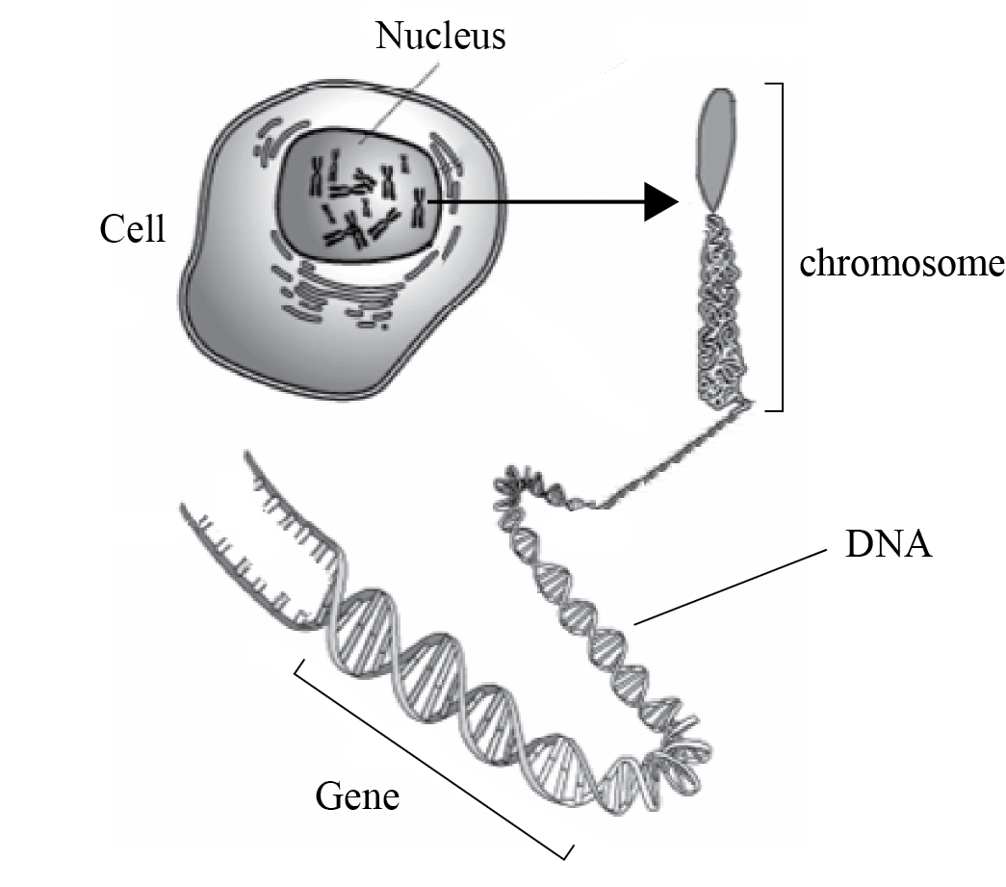  DNA – contains the genetic instructions (used in the development and functioning of proteins).  Gene – a section of DNA that codes for a particular protein / feature/characteristic.  Chromosome – an (organised) structure of DNA (found in the nucleus of a cell).  Explanation of link between DNA, chromosomes and genes.  DNA is the heredity material of the cell which is found in the chromosomes in the nucleus. These are found as strands each one of these strands of DNA is called a chromosome.  A gene is a segment of DNA, found in a small section of the chromosome. Along the DNA, base sequences provide the code for building different proteins, which then determine particular features. Slight differences in the sequence of the bases making up a gene are called alleles and they cause the variations in the phenotypes. These differences lead to genetic variation between individuals. |  |  | - Describes TWO of a gene, chromosome or DNA.  - Links all 3 terms  - Indicates that a different base sequence or alleles or chromosome combinations results in differing features/variation  - Describes genetic variation as differences in phenotypes between individuals  Note: May use labelled diagram to show description(s). |  | - Shows in-depth understanding of linkages between all 3 terms (DNA, genes, chromosomes)  - Explains the difference between a gene and an allele in terms of how they impact on features.  - Explains that the (DNA) base sequence on a gene determines the appearance of a particular feature / protein.  - Explains how chromosomes and genes are found in pairs with one from each parent giving possible variation. |  | - Discussion which links the explanation of the (structural) relationship between DNA, chromosomes, genes (and alleles) with the production of a particular feature / protein, resulting in variation of features/phenotypes.
 | NØ | N1 | N2 | A3 | A4 | M5 | M6 | E7 | E8
 | No response OR no relevant evidence.. | Describes partial idea, eg one correct label. | Describes ONE idea. | Describes TWO ideas. | Describes THREE ideas. | Covers ONE idea. | Covers TWO ideas. | Discussion includes linkage between the terms and implies variation. | Discussion includes full linkage between all THREE terms and relates directly to variation.

Q | Expected Coverage |  |  |  | Achievement |  | Merit |  | Excellence
TWO  (a)  (b)(i)  (ii) | Genotype of child with sickle cell anaemia – hh  Genotype of both parents – Hh  Explanation  Each child / fertilisation has an equal one in four chance of producing a child with sickle cells. This is because in the process of gamete formation / during meiosis alleles are randomly assorted.  Previous conceptions have no effect on future offspring; each is separate event.  Chances of fifth child having sickle cells is still one in four, as previous conceptions have no effect on this child; it is a new random event. |  |  |  | - Correct Punnett square OR genotype of both parents–Hh.  - Correct genotype of child – hh.  - Statement that each subsequent child has one in four chance of having sickle cells. |  | - Clear explanation that two normal parents Hh x Hh have 1 in 4 (25%) chance of producing a child with sickle cell anaemia by each donating the recessive h allele.  - Clear explanation that EACH fertilisation has equal chance of producing a child with sickle cells (ie 25%) because of the random assortment of alleles during gamete formation.  - Explains that fifth child has one in four chance of having sickle shaped cells, as previous conceptions have no effect on this child, it is a new random event. |  | Links the theoretical probabilities derived from the correctly completed Punnett Square with the explanation of why the actual outcomes for families will not necessarily match the predicted outcomes, and that each fertilisation is the result of gamete formation where each of the heterozygous parents may give either the recessive (h) or dominant (H) allele. Must clearly state that each fertilisation is a separate event and that no previous children affect the chance of subsequent children having sickle cells.
   | H | h
  H | HH | Hh
  h | Hh | hh
 |  | NØ | N1 | N2 | A3 | A4 | M5 | M6 | E7 | E8
 |  | No response OR no relevant evidence. | Describes ONE partial idea, eg correct genotype of one parent Hh but second parent incorrect. | Describes ONE idea, eg correct Punnett. | Describes TWO ideas, eg correct Punnet square plus correct genotype of child as hh. | Describes THREE ideas. | Covers ONE aspect. | Covers TWO aspects. | Discussion with minor error (eg no link to prior children) | Discussion fully explores the above

Q | Expected Coverage |  |  | Achievement |  | Merit |  | Excellence
THREE | Gamete formation by meiosis  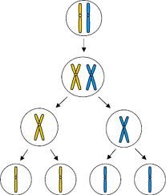  Description of meiosis: produces gametes/sex cells which have half the normal number of chromosomes as body cells.  Process of fertilisation: Random male and female gametes join, producing a unique zygote.  Role of sexual reproduction: Random assortment of chromosomes in meiosis and random fertilisation produce variation between individuals.  (Description of genetic variation: Genetic variation refers to a variety of different genotypes for a particular trait within a population).  Explanation: The advantage of variation to a species is that it may enable some individuals to survive if some threatening event occurs, eg disease or drought, as they will reproduce and pass on favourable phenotypes to strengthen the species. |  |  | - Description or diagram of gamete formation (meiosis) – must state/show HALF number of chromosomes.  - Description of fertilisation as fusion of male and female gametes.  - Describes how genetic variation leads to increased chance of survival. |  | - Clearly links sexual reproduction to genetic diversity – ideas of randomness in formation of gamete and / or fertilisation expressed.  - Explains link between genetic variation and increased survival of the species/population |  | - Comprehensive discussion that shows integration of ideas and linkage between sexual reproduction and increased species survival. A clear and detailed understanding of gamete formation and fertilisation, which leads to genetic diversity, is essential. A comprehensive understanding of how factors such as drought, disease etc will cause favourable characteristics/ phenotypes to be passed on to offspring to increase survival of the species/population.
 | NØ | N1 | N2 | A3 | A4 | M5 | M6 | E7 | E8
 | No response OR no relevant evidence. | Describes partial idea. | Describes ONE idea. | Describes TWO ideas. | Describes THREE ideas. | Covers ONE idea. | Covers TWO ideas. | Discussion shows clear linkage between sexual reproduction and survival. | Discussion is comprehensive and linkage between sexual reproduction and survival is detailed.

Q | Expected Coverage |  |  | Achievement |  | Merit |  | Excellence
FOUR | Definition of Phenotype  The physical expression of genotype / alleles, eg light and dark body / wings.  Explanation – colour  White bodied moths are more visible on a dark background and easily preyed upon. Dark coloured moths are more visible against a light / lichen background.  Explanation – environment  Individuals that are best suited to an environment will survive to reproduce and pass on their genes to future generations. This will lead to increase in numbers of the moth with an advantageous phenotype.  If the environment changes, eg trees become darker, those individuals with dark bodies will have the beneficial characteristic and pass this onto their offspring, while the light coloured moths will stand out and be preyed upon, therefore reducing in number. As a result the phenotypic ratio will change to more dark than light over time. |  |  | - Definition of phenotype.  - Mentions idea of hiding (camouflage) in context of predators.  - Describes that variation in phenotype leads to increased chance of survival for species (natural selection). |  | - Clearly links phenotype with survival of individual moths as the environment changes.  - Explains link between phenotype variation and increased survival of the moth species/population due to environmental change |  | - Comprehensive discussion which shows integration of ideas, and linkage between phenotype and survival, eg the proportion of dark moths will increase over time if the trees darken (or v.v.)  - Demonstrates comprehensive understanding of how selection pressures in a changing environment will affect the gene pool of species and consequently how phenotypic ratios will change as the camouflaged moths breed to sustain the species over time.
 | NØ | N1 | N2 | A3 | A4 | M5 | M6 | E7 | E8
 | No response OR no relevant evidence | Describes partial idea, eg mentions camouflage. | Describes ONE idea, eg correct definition of phenotype. | Describes TWO ideas. | Describes THREE ideas. | Covers ONE idea. | Covers TWO ideas. | Both points – one may be weaker. | Both points fully covered.

Judgement Statement
 | Not Achieved | Achievement | Achievement  with Merit | Achievement  with Excellence
Score range | 0 – 9 | 10 – 16 | 17 – 24 | 25 – 32

